Random Numbers

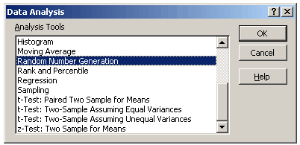
Excel has a RAND function and a RANDBETWEEN function.
These functions will only return numbers within a particular range
For more advanced random numbers you can use the Random Number Generation dialog box.
This gives you much greater control
number of variables - the number of columns
number of random numbers - how many values to return per column
random seed/selection - using this number in another session will return the same random number

Types of Distribution
Uniform | High and Low values.  Characterized by lower and upper bounds. Variables are drawn with equal probability from all values in the range. A common application uses a uniform distribution in the range 0...1.
Normal | Mean and standard deviation.  Characterized by a mean and a standard deviation. A common application uses a mean of 0 and a standard deviation of 1 for the standard normal distribution.
Bernoulli | P value.  Characterized by a probability of success (p value) on a given trial. Bernoulli random variables have the value 0 or 1. For example, you can draw a uniform random variable in the range 0...1. If the variable is less than or equal to the probability of success, the Bernoulli random variable is assigned the value 1; otherwise, it is assigned the value 0.
Binomial | P value and number of trials.  Characterized by a probability of success (p value) for a number of trials. For example, you can generate number-of-trials Bernoulli random variables, the sum of which is a binomial random variable.
Poisson | Lambda  Characterized by a value lambda, equal to the parameter μ is often replaced by λ.. Poisson distribution is often used to characterize the number of events that occur per unit of time for example, the average rate at which cars arrive at a toll plaza.
Patterned | Low, High, Step, No of repeats  Characterized by a lower and upper bound, a step, repetition rate for values, and repetition rate for the sequence.
Discrete | Value and probability  Characterized by a value and the associated probability range. The range must contain two columns: The left column contains values, and the right column contains probabilities associated with the value in that row. The sum of the probabilities must be 1.

Using Random Number Generation

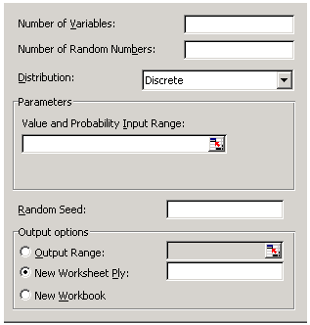
Number of Variables - Enter the number of columns of values you want in the output table. If you do not enter a number, Microsoft Excel fills all columns in the output range you specify.
Number of Random Numbers - Enter the number of data points you want to see. Each data point appears in a row of the output table. If you do not enter a number, Excel fills all rows in the output range you specify.
Distribution - Click the distribution method you want to use to create random values.
Parameters - Enter values to characterize the distribution selected.
Random Seed - Enter an optional value from which to generate random numbers. You can reuse this value later to produce the same random numbers.
Output Range - Enter the reference for the upper-left cell of the output table. Excel automatically determines the size of the output area and displays a message if the output table will replace existing data.
New Worksheet Ply - Click to insert a new worksheet in the current workbook and paste the results starting at cell A1 of the new worksheet. To name the new worksheet, type a name in the box.
New Workbook - Click to create a new workbook and paste the results on a new worksheet in the new workbook.
The Random Number Generation analysis tool fills a range with independent random numbers drawn from one of several distributions. You can characterise subjects in a population with a probability distribution.
For example, you might use a normal distribution to characterize the population of individuals' heights, or you might use a Bernoulli distribution of two possible outcomes to characterize the population of coin-flip results.

